Brett Stelly

Rendering Geometry

**Ability to load shaders from file using a Shader class object.**

This is a picture of my shader class. This class contains:

* Constant char pointers for the vertex and fragment shader file sources
* Unsigned ints for the vertex and fragment shaders
* Strings to store all of the text in the vertex and fragment shader file sources
* Unsigned int for the shader program

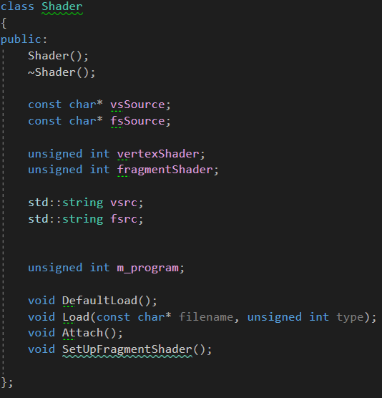

Here are pictures of the process that takes place for reading and loading shaders from a file when the Load function on a shader object is called.

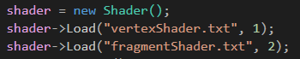

I call Load twice. Once to load the vertex shader, and again to load the fragment shader.

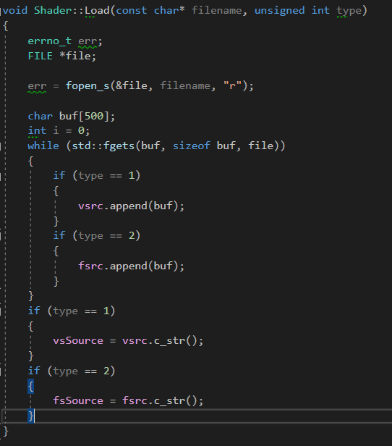

Once both vertex and fragment shaders are loaded, I call the shaders Attach function to compile the shaders.

